Experiment 1: CSS for Student Registration Form

< html>
<head>
<link rel="stylesheet" href="1.css">
</head>
<body>
<div class="form-container">
<form>
<label>Full Name</label>
<input type="text" placeholder="enter your name:" />
<label>Email</label>
<input type="password" placeholder="enter your password">
<label>
<select>
<option>select course</option>
<option>BCA</option>
<option>BBA</option>
<option>B.Tech</option>
</select>
<button type="submit">Register</button>
</label>
</form>
</div> </body></html>
body {
margin:0;
padding: 0;
background:linear-gradient(to right,rgb(199, 247, 219),rgb(188, 188, 192));
}
.form-container {
display:flex;
justify-content: center;
align-items: center;
height:100vh;
}
form label {
display:block;
color:#555;
margin:15px;
}
form input {
color:black;
border: solid green 5px;
border-radius: 5px;
}
form select,button {
margin:5px 5px;
padding:5px 5px;
}
button:hover {
background-color: blue;
transition: 0.3s;
}
OUTPUT:
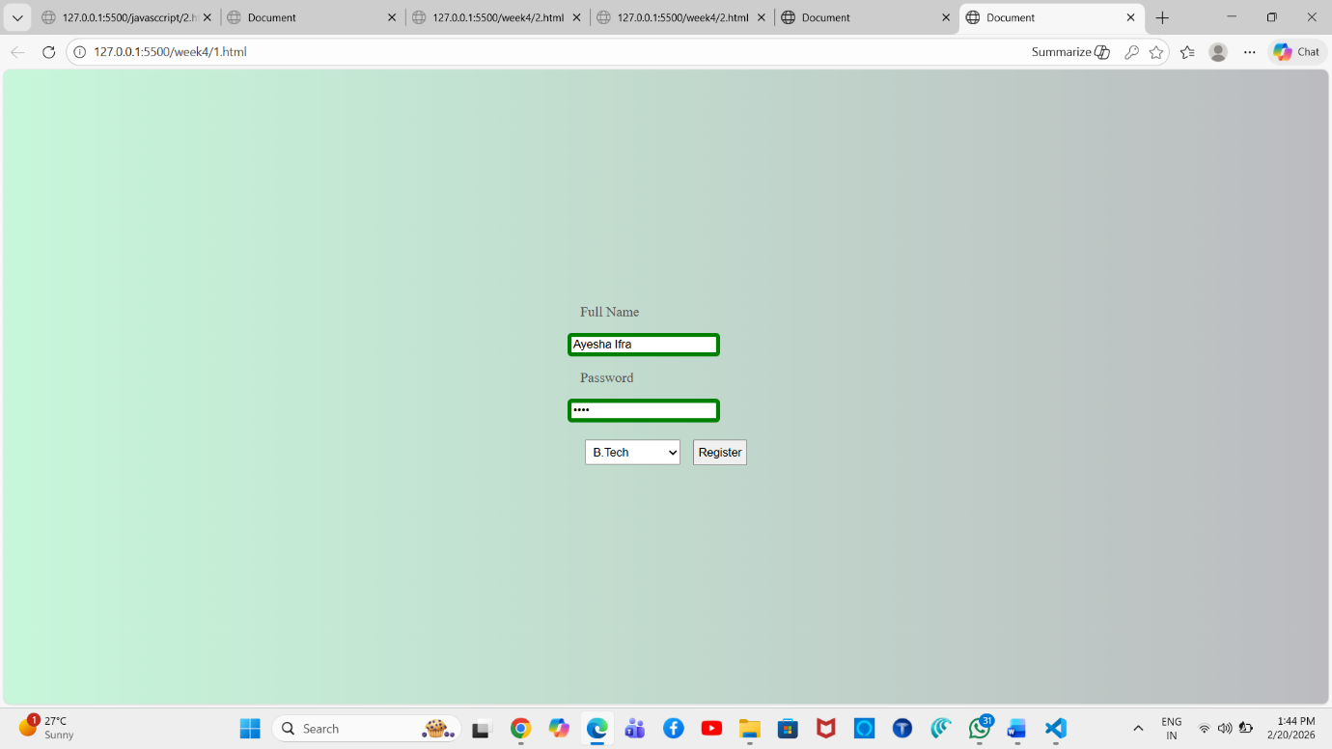

Experiment 2: CSS for Timetable Table

<!DOCTYPE html>
<html lang="en">
<head>
<link rel="stylesheet" href="2.css">
</head>
<body>
<table border="1" cellspacing="0" cellpadding="10">
<tr>
<th rowspan="2">period<br>Day/time</th>
<th>I</th>
<th>II</th>
<th>III</th>
<th rowspan="2">12:15 to <br>1:00 PM</th>
<th>IV</th>
<th>V</th>
<th>VI</th>
</tr>
<tr class="time-row">
<th>9:10 to 10:10</th>
<th>10:10 to 11:10</th>
<th>11:10 to 12:10</th>
<th>1:00 to 2:00</th>
<th>2:00 to 3:00</th>
<th>3:05 to 4:05</th>
</tr>
<tr>
<td class="day-column">MONDAY</td>
<td>PE-I</td>
<td>EEA</td>
<td>PQT</td>
<td rowspan="5" class="lunch-cell">LUNCH BREAK</td>
<td>DBMS</td>
<td>LIBRARY</td>
<td>SPORTS</td>
</tr>
<tr>
<td class="day-column">TUESDAY</td>
<td colspan="2">DBMS LAB(B1) <br> MP-I(B3)</td>
<td>EAD LAB (B2) <br> LIBRARY(B3)</td>
<td>PQT</td>
<td>EEA</td>
<td>ES</td>
</tr>
<td class="day-column">WEDNESDAY</td>
<td>EAD</td>
<td>PE-I</td>
<td>PQT</td>
<td colspan="2" >DBMS LAB(B2) <br>
LIBRARY(B1)</td>
<td>EAD LAB(B3) <br> MP-1(B1)</td>
</td>
</tr>
<td class="day-column">THURSDAY</td>
<td>DBMS</td>
<td>EEA</td>
<td>EAD</td>
<td>PE-I</td>
<td>ES</td>
<td>PQT (T)</td>
</tr>
<tr>
<td class="day-column">FRIDAY</td>
<td colspan="2">DBMS LAB</td>
<td>LIBRARY (B2)</td>
<td>DBMS</td>
<td>EAD</td>
<td>MENTORING</td>
</tr>
</table>
</body> </html>
body{
padding:0;
margin:0;
}
.formcont {
display: block;
justify-content: center;
width:250px;

align-items: center;
margin:25px;
padding:5px 5px;
border:5px solid black;
}
form {
display:flex;
flex-direction: column;
gap:15px;
}
textarea {
height:120px;
}
input:focus,textarea:focus,select:focus {
border:2px solid blue;
}
OUTPUT:
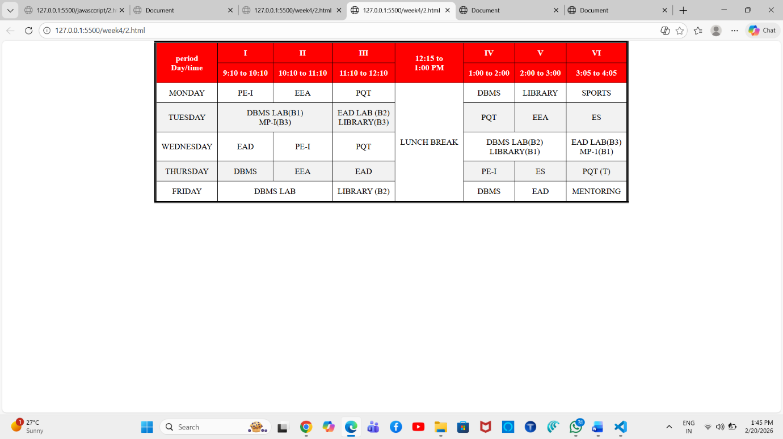

Experiment 3: CSS for Feedback Form
<html>
<head>
<link rel="stylesheet" href="3.css">
<title>Document</title>
</head>
<body>
<div class="formcont">
<form >
<label>Full Name</label>
<input type="text" placeholder="enter your name:" />
<label>Email</label>
<input type="password" placeholder="enter your password">
<label>
<select>
<option>ratings</option>
<option>excellent</option>
<option>good</option>
<option>average</option>
</select>
<button type="submit">Register</button>
</form>
</div>
</body> </html>
body{
font-family: Arial, Helvetica, sans-serif;
margin:0;
}
.formcont {
width:250px;
margin:50px auto;
padding:15px;
border:5px solid black;
}
form {
display:flex;
flex-direction: column;
gap:15px;
}
textarea {
height:120px;
width:100%;
}
input:focus,textarea:focus,select:focus {
border:2px solid blue;
}

OUTPUT:
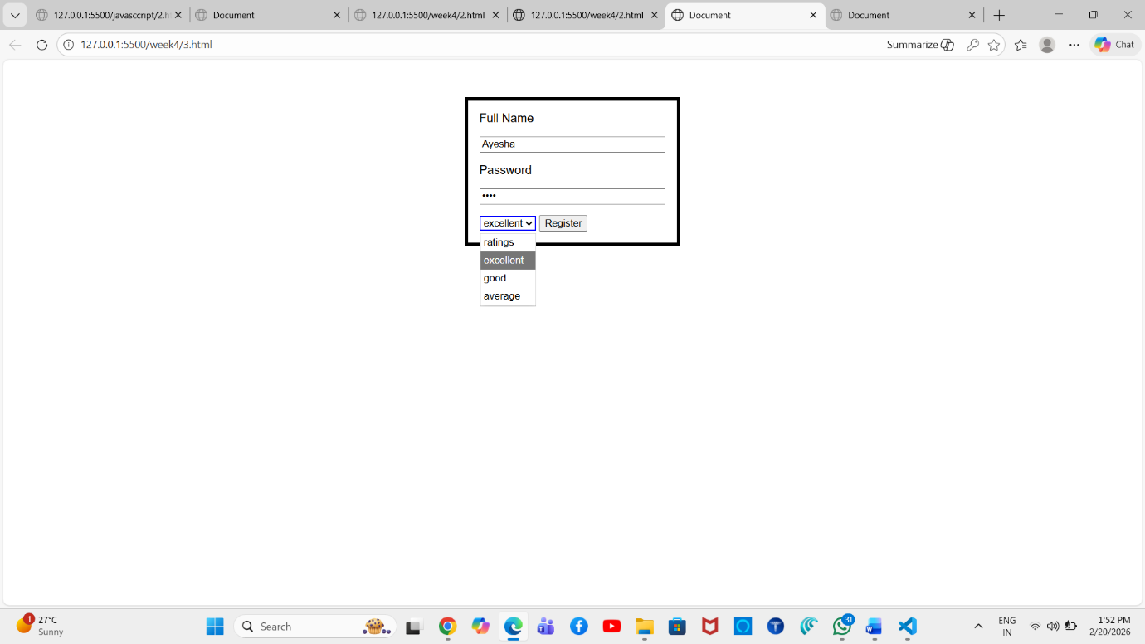

Experiment 4: CSS for MERN Stack Web Page

<html>
<head>
<link rel="stylesheet" href="4.css">
</head>
<body>
<div class="page">
<h1>mern tech</h1>
<p>Lorem ipsum dolor sit amet consectetur, adipisicing elit. Dolor odio totam dolorem quia quibusdam quos ipsam placeat.</p>
<a href="https://www.mongodb.com/" target="_blank">Visit Official MongoDB Website →</a>
<ol>
<li>mongo
</li>
<li>express</li>
<li>react</li>
<li>node</li>
</ol>
<img src="mern_stack_diagram.png" alt="MERN Stack Diagram" class="mern-image" width="500px" height="500px">
</div>
</body>
</html>

h1 {
color:blueviolet;
font-family: 'Franklin Gothic Medium', 'Arial Narrow', Arial, sans-serif;
font-weight: 300;
}
.page {
display:flex;
flex-direction: column;
justify-content: center;
align-items: center;
text-align: center;
}
p{
font-size:18px;
line-height:1.6;
max-width: 700px;
}
ol {
background: #f3f3f3;
padding:15px 30px;
border-radius:10px;
}
li{
margin:5px 0;
font-weight:bold;
}
.mern-image{
border:4px solid black;
box-shadow:3px 3px 10px gray;
border-radius:10px;
}

a:hover{
color:white;
background:blue;
padding:5px 10px;
border-radius:5px;
}

OUTPUT:
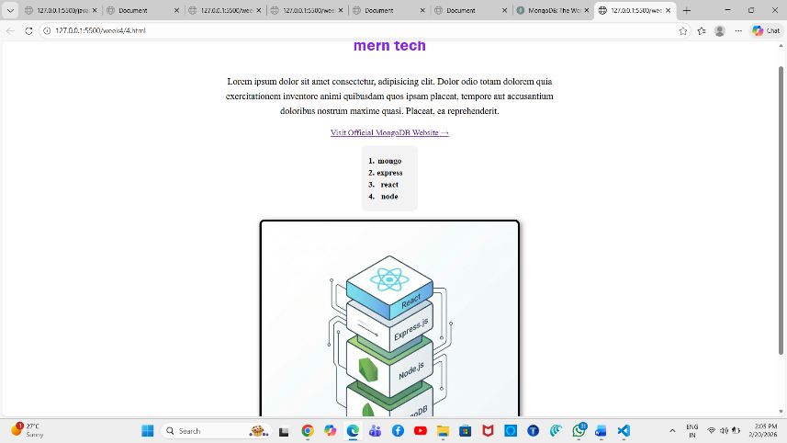

Experiment 5: CSS for Fieldset and Legend

<html>
<head>
</head>
<body>
<form>
<fieldset>
<legend>Personal Information</legend>
<label>Full Name</label>
<input type="text" placeholder="Enter your name">
<label>Email</label>
<input type="email" placeholder="Enter your email">
</fieldset>
<fieldset>
<legend>Account Details</legend>
<label>Password</label>
<input type="password" placeholder="Enter your password">
<label>Ratings</label>
<select>
<option>excellent</option>
<option>good</option>
<option>average</option>
</select>
</fieldset>
<button type="submit">Register</button>
</form>
</body>
</html>
CSS CODE:
input,select {
display:flex;
flex-direction: column;
gap:5px;
width:100%;
padding:10px;
margin-bottom:5px;
box-sizing: border-box;
}
OUTPUT:
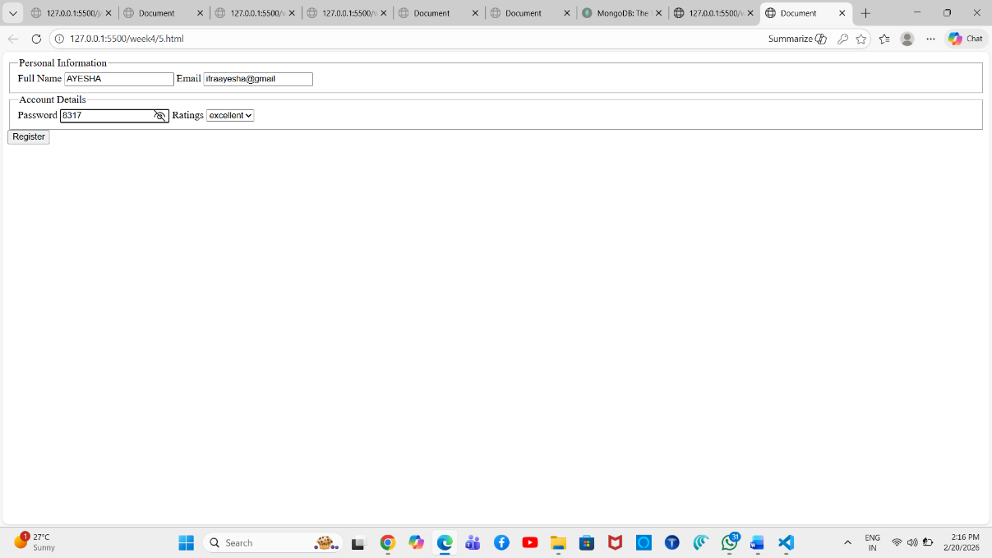

Experiment 6: CSS for Resume Page

<html>
<head>
<link rel="stylesheet" href="6.css">
</head>
<body>
<div class="resume">
<h1>Ayesha Ifra</h1>
<p>
Email: example@gmail.com <br>
PhoneNo: 1234567890 <br>
Address: xxxxxxxxxxx
</p>
<h2>Education</h2>
<table>
<tr>
<th>Institute</th>
<th>Qualification</th>
<th>Percentage</th>
</tr>
<tr>
<td>M.A Ideal High School</td>
<td>SSC Passed</td>
<td>9.2</td>
</tr>
<tr>
<td>Quli Qutub Shah Govt Polytechnic</td>
<td>Diploma Passed</td>
<td>9.6</td>
</tr>
<tr>
<td>CBIT</td>
<td>2nd Year</td>
<td>100</td>
</tr>
</table>
<h2>Skills</h2>
<ol>
<li>C</li>
<li>C++</li>
<li>Java</li>
<li>Python</li>
<li>HTML</li>
<li>CSS</li>
</ol>
</div>
</body> </html>
body{
font-family: "Times New Roman", serif;
background:#f4f4f4;
margin:0;
}
.resume{
width:600px;
margin:40px auto;
background:white;
padding:25px;
box-shadow:0 0 10px gray;
border-radius:10px;
}
h1{
text-align:center;
color:#2c3e50;
border-bottom:3px solid #3498db;
padding-bottom:10px;
}
h2{
color:#3498db;
}
p{
line-height:1.6;
}
table{
width:100%;
border-collapse:collapse;
margin-top:15px;
}
th,td{
border:1px solid black;
padding:10px;
text-align:center;
}
th{
background:#3498db;
color:white;
}
tr:nth-child(even){
background:#f2f2f2;
}
ol{
margin-top:15px;
}
li{
padding:4px;
}

OUTPUT:
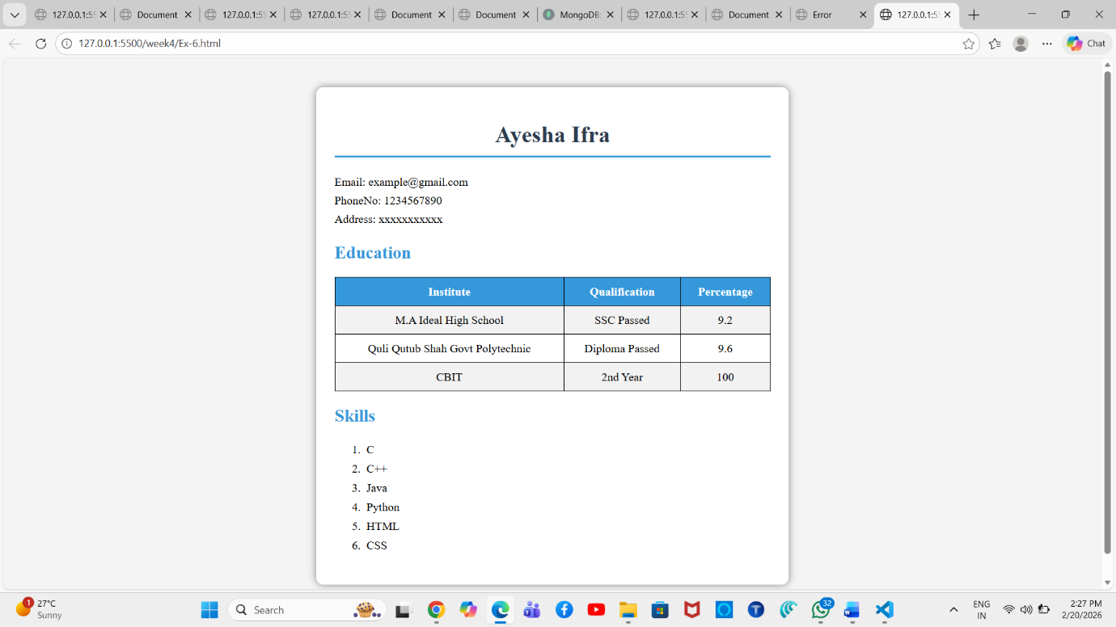

Experiment 7: Chess Board Using HTML and CSS

<html>
<head>
<link rel="stylesheet" href="7.css">
<body>
<table class="board">
<tbody>
<tr>
<td></td><td></td><td></td><td></td><td></td><td></td><td></td><td></td>
</tr>
<tr>
<td></td><td></td><td></td><td></td><td></td><td></td><td></td><td></td>
</tr>
<tr>
<td></td><td></td><td></td><td></td><td></td><td></td><td></td><td></td>
</tr>
<tr>
<td></td><td></td><td></td><td></td><td></td><td></td><td></td><td></td>
</tr>
<tr>
<td></td><td></td><td></td><td></td><td></td><td></td><td></td><td></td>
</tr>
<tr>
<td></td><td></td><td></td><td></td><td></td><td></td><td></td><td></td>
</tr>
<tr>
<td></td><td></td><td></td><td></td><td></td><td></td><td></td><td></td>
</tr>
<tr>
<td></td><td></td><td></td><td></td><td></td><td></td><td></td><td></td>
</tr>
</tbody>
</table>
</body>
</html>

body{
display: flex;
justify-content: center;
align-items: center;
height: 100vh;
margin: 0;
}

.board{
border-collapse:collapse;
}

td{
width:60px;
height:60px;
}
tr:nth-child(even) td:nth-child(even),
tr:nth-child(odd) td:nth-child(odd){
background:white;
}
tr:nth-child(even) td:nth-child(odd),
tr:nth-child(odd) td:nth-child(even){
background:black;
}
OUTPUT:
